

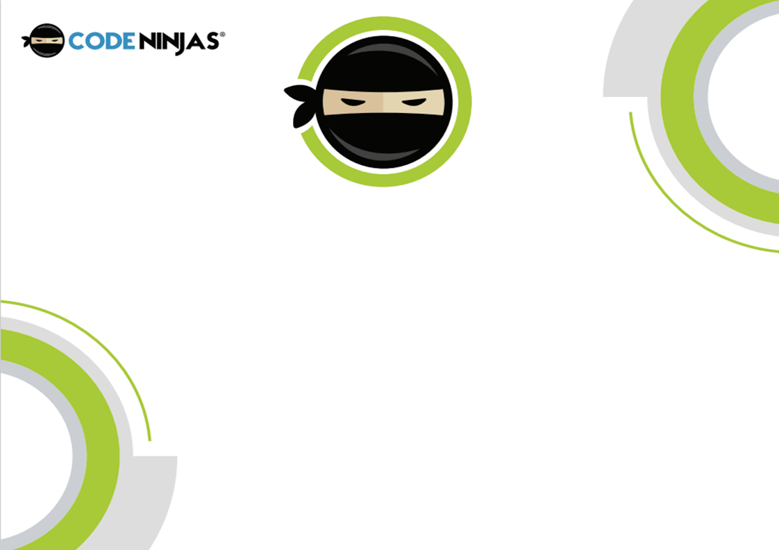

In this session +CHILDNAME+ had to bring everything together to ensure that +hisher+ project was as good as can be!

From multi-million dollar Hollywood projects to stop motion animation filmed in a bedroom, editing and post-production is often known as the real magic of the storytelling process. Here we can rehash ideas, incorporate feedback and ensure the project is visually compelling and as structurally coherent as we originally intended!

We furthered the basics today from having a peek at editing at the beginning of the camp. +CHILDNAME+ was using Windows Video Editor, which is  very accessible tool with a  full-featured set of video creation and editing tools that +heshe+ can use to tell our new story with!

+CHILDNAME+ bolstered the original video with some music, text, motion, and 3D effects! We also clipped and trimmed the footage to create flow and for either a more dramatic or comedic effect.  Combining this focus today with the easy-to-use creative tools, enabled +himher+ with the means to show off a great story!

Amazing stuff superstar, let’s hope not too much golden content was left on the cutting room floor!

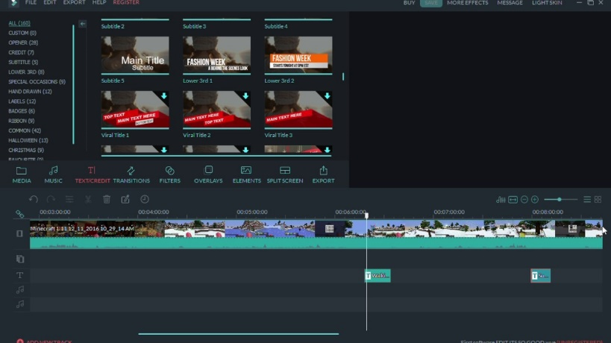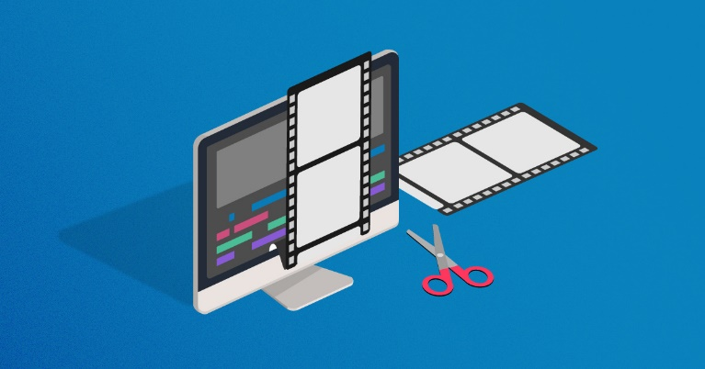



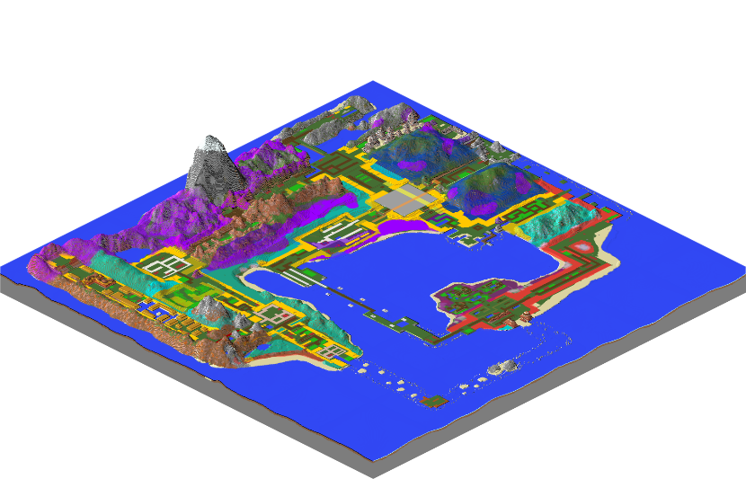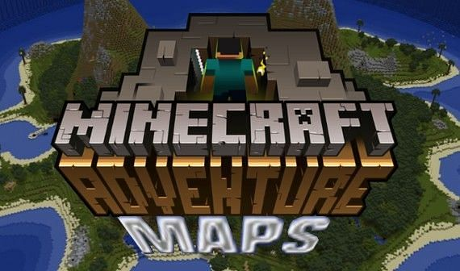

For this dojo session, it was all about +CHILDNAME+ transitioning into the next stage of our project work!

Similarly to the beginning of the Camp, +CHILDNAME+ researched and imported a custom Adventure Map to scout and explore - not too dissimilar to location scouting on a real live-action masterpiece!

For those of you not in the loop (who can blame you!?) Minecraft adventure maps are self-contained experiences that are less about building and more about exploring, battling, uncovering plots and secrets. Navigating exotics locations, dealing with traps and solving puzzles are all to be expected on these journeys! While many of them can be quite happily played solo, a team of up to 4 others can be made in multiplayer.

I’m sure +CHILDNAME+ can present a list of their favourite YouTubers and if they are Minecraft Creators, it is likely they have many projects which are dedicated to playthroughs of Adventure Maps.

So, in the style of their favourite creator, injected with some of their own personality. +CHILDNAME+ has begun work on their own version of a ‘Let’s Play’ using all of the storytelling and filmmaking skills learnt and developed up until now!

I’m excited to see the final product!

